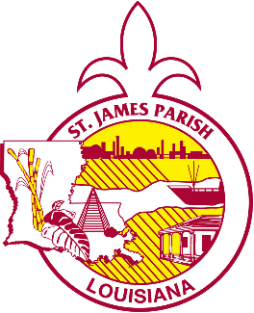





St. James Parish Government

COMMUNICATIONS

facebook.com/stjamesparishla www.stjamesla.com
225-264-3309

publicinformation@stjamesla.com

FOR IMMEDIATE RELEASE
April 25, 2023

St. James Parish Launches Capital Improvement Plan Survey

St. James Parish, LA - St. James Parish has launched a Capital Improvement Plan (CIP) survey to gather input from residents on future infrastructure and facility improvements. The CIP survey will be open for responses from April 25 until May 31, 2023.

The Capital Improvement Plan lays a framework and creates a plan for major projects over the next several years. The survey aims to gather feedback from St. James Parish residents to help the Parish prioritize its capital improvement projects. The information gathered will be used to identify what is most important to the residents of St. James Parish.

Parish President Pete Dufresne says, “Over the last three years, we have worked tirelessly to make major improvements throughout St. James Parish. However, there is always more to be done. As we continue to develop and refine our Capital Improvement Plan, this survey will allow us to identify what is most important to the residents of St. James Parish. I am looking forward to this new plan which will help prioritize our most pressing projects and needs, and equip us to build a better, stronger, and brighter future for St. James Parish.”

The survey can be completed online at stjamesla.com/477/Capital-Improvement-Plan-Survey. Printed copies of the survey are also available at the following locations:

- Vacherie Library - 2593 Highway 20, Vacherie, LA 70090
- Lutcher Library - 1879 W Main St, Lutcher, LA 70071
- Convent Courthouse - 5800 La 44, Convent, LA 70723

