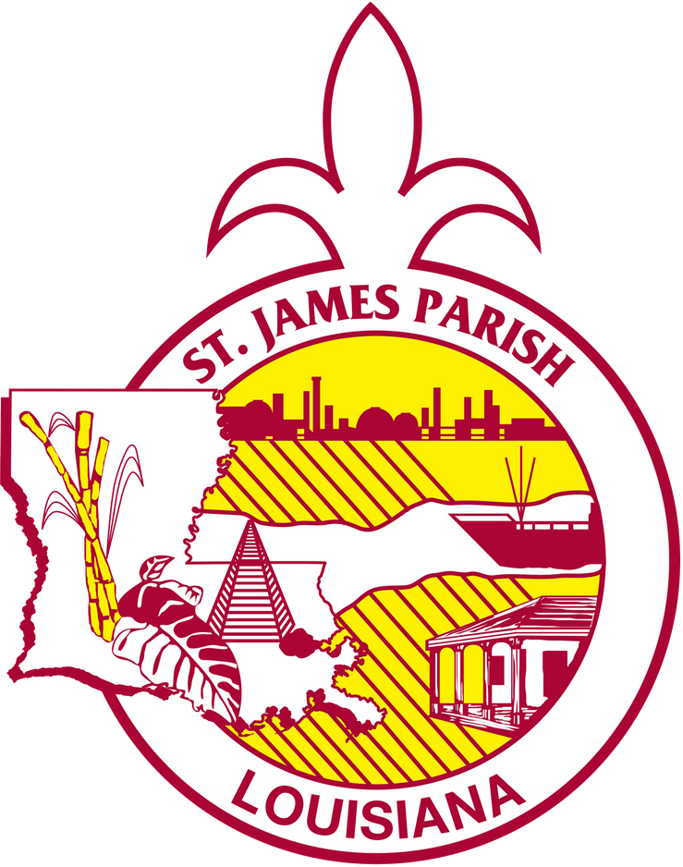

St. James Parish Government

COMMUNICATIONS

facebook.com/stjamesparishla www.stjamesla.com
225-264-3309

publicinformation@stjamesla.com

FOR IMMEDIATE RELEASE
May 22nd, 2024

St. James Parish Libraries Launch Mobile Book Services

St. James Parish, Louisiana,– St. James Parish Libraries is delighted to announce the relaunch of its Mobile Library Service, a dynamic initiative aimed at bringing literature and educational resources directly to the residents of St. James Parish.

With the primary goal of fostering a love for reading and learning within the community, the Mobile Library Service offers a wide array of books, magazines, and educational materials, ensuring that individuals of all ages and interests have access to quality reading material regardless of their location. The Mobile Library Service strives to bridge the gap between readers and books, thereby promoting literacy and intellectual engagement.

"We are thrilled to reintroduce our Mobile Library Service to the community," said Keri Walker Tramonte, Supervisor of the St. James Parish Libraries. "At St. James Parish Libraries, we believe that everyone should have access to literature and educational resources, regardless of their circumstances. With the relaunch of our Mobile Library Service, we aim to reach even more individuals and inspire a lifelong love for reading and learning."

The Mobile Library Services offer a collection of diverse genres and subjects, in large print, cd, and traditional book formats to cater to the varied interests and preferences of its patrons. Participants can choose from a variety of options, including fiction, non-fiction, best sellers, children’s books, classics, dramas, family stories, historical romance, science fiction, westerns, biographies, cooking/recipes, gardening, health, history, poetry, self-help, travel, magazines, and much more.

Individuals interested in participating can fill out a printed or online form and set up an in-person conversation or phone conversation to discuss preferences on materials.

Register today at stjamesla.com, or by calling 225-562-3618.

