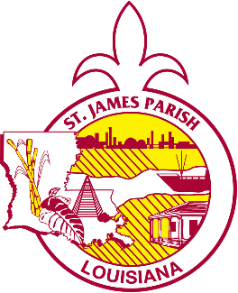





St. James Parish Government

COMMUNICATIONS

facebook.com/stjamesparishla www.stjamesla.com
225-264-3309

publicinformation@stjamesla.com

IMMEDIATE RELEASE
April 2, 2024

Councilman Louque to Host District 3 Community Meeting

On April 11th at 6:00pm, Councilman Ryan Louque, Parish President Pete Dufresne, and St. James Parish staff members will be hosting a Community Meeting at 6:00pm at Grace Church of Paulina.

Councilman Ryan Louque said, “This Community Meeting is a great way for District 3 to hear details on current events within St. James Parish. A lot of work has been accomplished in District 3 over the last few years, and there are many major projects to come.”

Agenda Highlights:
- West Shore Connector Levee Updates: Learn about the latest developments regarding the West Shore Connector Levee project.
- District 3 Projects Overview:
  - Explore past accomplishments and ongoing initiatives.
  - Get insights into future projects that will benefit our community.
- Proposed Millage Details: Understand how the proposed millage will impact essential services:
  - Solid waste/garbage collection and disposal (including tree limb pick up and transfer sites)
  - Animal control officer
  - Operation, improvements, and maintenance of recreational facilities and parks
  - Construction, improvement, and maintenance of public roads and bridges

Parish President Pete Dufresne said, “I am looking forward to attending this meeting and will be happy to answer any questions the public may have. If you would like to discuss how this millage would affect you personally, please bring a copy of your 2023 tax bill to review.”

Event details:
April 11, 6:00pm
Grace Church of Paulina
39316 Industrial Park St
Paulina, LA 70763

