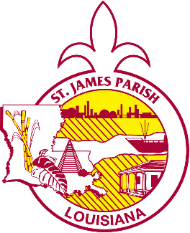





St. James Parish Government

COMMUNICATIONS

facebook.com/stjamesparishla www.stjamesla.com
225-264-3309

publicinformation@stjamesla.com

IMMEDIATE RELEASE
March 22, 2024
St. James Parish Hosts April Market Day

On Saturday, April 13th, St James Parish will be hosting its second monthly Market Day Event for 2024.

The St James Parish Market Day is held the second Saturday of every month at the St James Parish Welcome Center. This event provides a venue for local farmers, vendors, small businesses, and micro businesses to sell their goods directly to our local community. Venders are invited to sell homemade products, produce, and food items.

Parish President Pete Dufresne said, “This event is something to look forward to every month. Our Market Day is a great chance to support many of our small businesses all in one location, and we’ve seen this event steadily grow with new vendors each and every month, as well as many return vendors.”

Market Day will be held on Saturday, April 13th, from 8:00A.M – 1:00P.M. at the Welcome Center, located at 1094 US-61 S, Gramercy, LA 70052. A constant rotation of shuttles is available from the Golden Grove Truck Stop, located at 935 Highway 641, Gramercy, LA 70052.

Economic Development Board member Brad Poche, who serves as Market Day Coordinator, said “This Market Day (farmers market) is being quoted by outside visitors as ‘The best Market in the River Parishes.’ Our locals should come out and experience this market day, mingle with friends, and have a delicious Cajun/Creole lunch.”

This month there is a wide variety of vendors and wares, including food, art, crafts, jewelry, candles, soap, honey, canned goods, embroidery, bath products, crochet, candy, holiday decor, wreaths, pastries, bread, baked goods, and more.

Learn more about the St James Parish Market Day at http://www.stjamesla.com/463/St-James-Parish-Market-Days, or by calling the Welcome Center at 225-562-2525.

