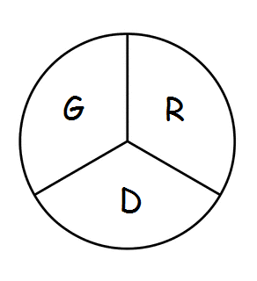 Gramercy Recreation District
P.O. Box 568 Gramercy, LA 70052
803rd Meeting
The Board of Commissioners of the Gramercy Recreation District held their regular monthly meeting on Monday, November 20th, 2023 at 5:00 p.m. at the St. James Parish Recreation Office in Gramercy, LA.
Chairman Smith called the meeting to order followed by roll call. Board members in attendance were: Shelton Smith, Craig Calcagno, Edward Johnson, and Todd Poche.
Also, in attendance were, Rick Weber, and Lindsay Szubinski.
Business Meeting: The minutes from October 23rd, 2023 were approved, 1st by Todd Poche and 2nd Edward Johnson
Monthly Expenditure Review:
- Review of financial reports for October, 2023 approved by Shelton Smith, Craig Calcagno, Edward Johnson, and Todd Poche.
Park Director’s Report:
- Rick Weber stated the council approved IGA, effective as the last council meeting, that a 10% handling fee, utilities, and the custodian salary will come out of the 059 account from the Parish for Gramercy Recreation.
- Rick stated he will get with Brandon and the custodian about the red ants throughout the park and the big stumps that need to be removed.
- Rick also stated Gramercy Recreation needs to talk to the town council and come back next month to have a public hearing with a millage.
- Discussion of an alternate meeting room was discussed and it was mention that upstairs in the park if need be or in the meeting room in convent, due to practice and games for Biddy Basketball.
- Lindsay Szubinski stated she put in a work order to remove the Porta Potty
- Get Mr. Scott the Architect in the next meeting to discuss the progress of the Master Plan.

Board Members Reports:
- Edward Johnson stated Park B needs a redo to the playground area with grounds cover (soft cushion)
- Craig Calcagno stated, Parish President Pete Dufrense is proposing a 6-mill tax {4 for garbage, 1 for recreation parish wide, 1 for animal control and stumps}
Motion to Adjourn: 1st by Todd Poche, 2nd by Craig Calcagno

