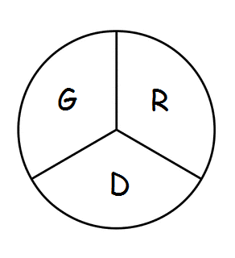 Gramercy Recreation District
P.O. Box 568 Gramercy, LA 70052
804th Meeting
The Board of Commissioners of the Gramercy Recreation District held their regular monthly meeting on Monday, December 18th, 2023 at 5:00 p.m. at the St. James Parish Recreation Office in Gramercy, LA.
Chairman Smith called the meeting to order followed by roll call. Board members in attendance were: Shelton Smith, Craig Calcagno, Edward Johnson.
Also, in attendance was, Rick Weber.
Business Meeting: The minutes from November 20th, 2023 were approved, 1st by Craig Calcagno and 2nd Edward Johnson
Monthly Expenditure Review:
- Review of financial reports for November, 2023 approved by Shelton Smith, Craig Calcagno, and Edward Johnson.
Old Business:
- Rick Weber will start writing P.O. in January for the bathroom designs and the Master Plan.
New Business:
- In Redoing the Play Area at Park B, a Picnic Table and Benches on Front End
- Walking track
- Put a perimeter fence around the fields
- Restroom in Park B needs lighting and fencing.
Board Members Reports:
- NONE
Motion to Adjourn: 1st by Edward Johnson, and 2nd by Craig Calcagno

