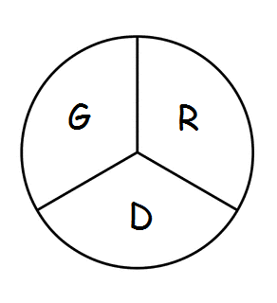 Gramercy Recreation District
P.O. Box 568 Gramercy, LA 70052
806th Meeting
The Board of Commissioners of the Gramercy Recreation District held their regular monthly meeting on Tuesday, February 20th, 2024 at 5:00 p.m. due to the fact Monday was President’s Day, at the St. James Parish Recreation Office in Gramercy, LA.
Chairman Smith called the meeting to order followed by roll call. Board members in attendance were: Shelton Smith, Craig Calcagno, Donald Arbuthnot
Also, in attendance was, Mark Heltz, Tevis Smith, Rick Weber, Courtney Long, Todd Poche, Dustin Falgoust, Scott Poirrier, and his assistant.
Chairman Comments: Mr. Donald Arbuthnot was welcomed to the board. Mr. Shelton stated he was kind of disturbed that the meeting in January got kind of out of hand, that is not the way he expects the board to operate. He respects each member and the have the right to make decisions as well. Mr. Shelton also stated to make sure the parliamentarian procedures are followed which gives the courtesy to not over talk one another, and only speak once the chairman approves you.
Business Meeting: The minutes from January 22nd meeting were approved, 1st by Craig Calcagno and 2nd Donald Arbuthnot
Monthly Expenditure Review:
- Review of financial reports for January 22nd
Old Business:
- Put Building lettering on buildings, ex. 412 N. Ezidore A
- Sign for park keep under $10,000, also put landscaping for Basic sign with solar lighting
- Hightide’s goal is in 2-3 weeks to have a packet on each project to send to bidders and allow 5-6 for pricing
- Restroom would take 120 days to build
- 11 contractors that made pre-bids opened on 02/20/2024 and 6 bids were returned.
- 4 projects were presented and was to be broken as its own separate scope, with Restroom being the biggest.
- Restroom- Base bid, electrical to accept havoc and be ac capable
- Pickle Ball Court the foundation, specs and coating were discussed. It will be fenced in 60x60; 1 pad requirement for falling.
- 36x32 4-person swing set with timber border, enclosed area with rubber mulch(bonded)
- Dustin, Tevis, Scott, his assistant, Rick and Courtney exited the meeting at 5:53 p.m.
- Motion to move forward with the projects with 3 quotes was 1st by Mr. Craig and 2nd by Mr. Donald
New Business:
- Mr. Donald stated the scoreboard that was previously on the park has no permanent power, which came from the rental building that is no longer there. The scoreboard lights up, but CAN’T OPERATE properly.
- Flag/Tackle Football begins in July
- Mr. Craig stated that soft surface needs for Park B is in pretty good condition with little to no use, and pine bark was used with no border which drew bugs so they got rid of it
Board Members Reports:
- NONE
Motion to Adjourn: 1st by Craig Calcagno, and 2nd by Donald Arbuthnot

