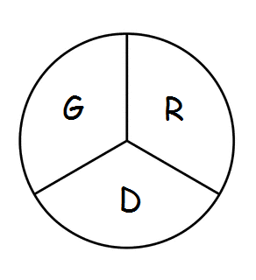 Gramercy Recreation District
P.O. Box 568 Gramercy, LA 70052
799th Meeting
The Board of Commissioners of the Gramercy Recreation District held their regular monthly meeting on Monday, June 26, 2023 at 5:00 p.m. at the St. James Parish Recreation Office in Gramercy, LA.
Chairman Smith called the meeting to order followed by roll call. Board members in attendance were: Shelton Smith, Craig Calcagno, Edward Johnson, and Todd Poche.
Also, in attendance were Rick Weber, Tevis Smith, and Scott Porrier
Absent: Cathy Bland
Business Meeting: Due to visitors the Agenda was revised to go to Old Business, Master Plan, Splash Park, and Work Orders.
Master Plan:
Scott Porrrier spoke on the Master Plan, the funding needed and what funding is on hand.
(Pickle Ball, The Rental Building {Eyesore}, Parking)
Splash Park
Craig stated that too much money was spent on a water line for a Splash Park is not working properly.

Work Order
Tevis stated that Unique Constructions was given the list by him, but they haven’t responded.
Board Members Reports
- Todd talked about trimming trees in the park.
- Edward stated that about 10ft of the park IS NOT getting cut.
- Edward was advised by Shelton to set up a meeting with the owner of the grass cutting business.
- Craig wants to incorporate the present custodians into maintenance/custodian position as of 08/01/23. It was motioned by Craig and seconded by Todd. {NO OPPOSITION 4-0}
- It was motioned by Edward to eliminate Park Director Position by 12/31/23, seconded by Craig. {NO OPPOSITION 4-0}
- Edward Johnson was concerned about the bathroom being built with cinderblocks but no air conditioner. He is also concerned about a concession stand for football.
- Craig brought up the idea of swings for the park which can be taken into consideration
- At the next monthly meeting Rick Weber wants to be on the Agenda
Rick Weber exited the meeting at 5:45 p.m.
Tevis Smith exited the meeting at 5:55 p.m.
With no other business to come before the Board, the meeting was adjourned. Motion to adjourn was made by Edward Johnson and seconded by Todd Poche.
The next monthly meeting will be held on July 17th 2023 at 5:00 p.m. at the Parish Recreation Office in Gramercy, LA

Aliska L Jones Franklin, Secretary

