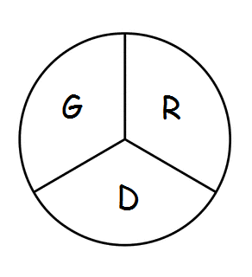 Gramercy Recreation District
P.O. Box 568 Gramercy, LA 70052
811th Meeting
The Board of Commissioners of the Gramercy Recreation District held their regular monthly meeting on Monday, August 19th, 2024 at 5:00 p.m., at the St. James Parish Recreation Office in Gramercy, LA.
Chairman Smith called the meeting to order followed by roll call. Board members in attendance were: Shelton Smith, Donald Arbuthnot, Craig Calcagno Edward Johnson, and Aliska Franklin.
*Brent Dicharry was ABSENT
Approval of the July 15th, 2024 meeting was motioned by Edward Johnson and 2nd by Craig Calcagno. Motion passed.
Monthly Expenditure Review:
- After viewing the Monthly Expenditure Edward Johnson stated that he had concerns about the monthly and yearly expenses with a breakdown of who’s being paid and what is being paid. He also suggested that a meeting should be set up with Paige Reulet or someone from finance.
- Craig Calcagno stated that he thought when the Parish took over a representative was supposed to be at the meeting and they aren’t holding up their end of the bargain.
- By no one being in attendance to answer the questions, the board members are NOT pleased because questions are not being answered that needs to be.
Old Business:
- As for the incomplete work orders no one knows who’s doing what on the projects and are they really being done? The objective is to find out where every penny is being spent
- Edward Johnson stated the signs in and for the park is a NECESSITY.
- The issue with the overnight parking the car was moved and a trailer was then put there and Craig Calcagno stated you can’t ENFORCE what’s NOT POSTED.
- Mr. Shelton said he was willing to call Rick Weber to see why someone was not available to attend the monthly meeting, and would request the financial employees to come to the meetings.
- The mileage renewal which is 4.36 was motioned to keep at present rate 1st by Edward Johnson and 2nd by Donald Arbuthnot
- Absentee Policy was discussed but was asked to be tabled until September’s meeting. Motioned by Craig Calcagno and 2nd by Donald Arbuthnot.
Board Members Reports
- Craig stated stated that out of the 50 work orders there is a broken pipe by the bathroom that needs fixing.
- Donald reported a hole by the gate by the tennis court.
- Shelton reported the land by the water tower was for the Hymels who will be donating it to the Gramercy Recreation Department.
Motion to Adjourn: 1st by Craig Calcagno, and 2nd by Donald Arbuthnot

