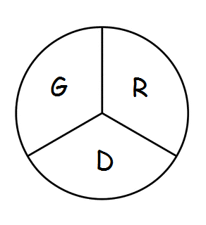 Gramercy Recreation District
P.O. Box 568 Gramercy, LA 70052
801st Meeting
The Board of Commissioners of the Gramercy Recreation District held their regular monthly meeting on Monday, August 28, 2023 at 5:00 p.m. at the St. James Parish Recreation Office in Gramercy, LA.
Chairman Smith called the meeting to order followed by roll call. Board members in attendance were: Shelton Smith, Craig Calcagno, Edward Johnson, and Todd Poche.
Absent: Cathy Bland
Also, in attendance were Pete Dufrense, Eric Deroche, Alvin St. Pierre, Rick Weber, Tevis Smith, and Lindsay Szubinski.
Business Meeting: The minutes from July, 2023 were approved
Monthly Expenditure Review: Reviewed for July 2023

