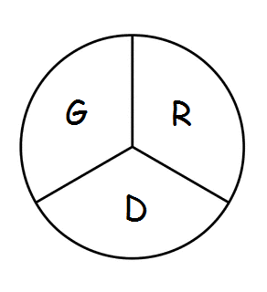 Gramercy Recreation District
P.O. Box 568 Gramercy, LA 70052
813th Meeting
The Board of Commissioners of the Gramercy Recreation District held their regular monthly meeting on Monday, October 21st, 2024 at 5:00 p.m., at the St. James Parish Recreation Office in Gramercy, LA.
Chairman Smith called the meeting to order followed by roll call. Board members in attendance were: Shelton Smith, Donald Arbuthnot, Craig Calcagno, Brent Dicharry. Aliska Franklin- Secretary in attendance as well.
*Edward Johnson was ABSENT
Approval of the September 16th, 2024 meeting was suspended until The November meeting. It was motioned by Craig Calcagno and 2nd by Donald Arbuthnot. Motion passed.
Ad Valore Tax: Read by Shelton Smith and discussed with Mr. Boughton to share the expense of the election (May 3, 2025) with the Parish. The Tax is a 10-year tax and it does expire. The assessor has to re-assess every year for the industry.
Project Updates:
- Rick Webre stated that for change of orders he has to go to the council to get approval and the council will make the decision.
- An ADA Playground with slab was allotted by Pete Dufrense
- Tevis Smith stated he put in a work order that was not there for a broken pipe, and it has been fixed.
- Any work orders needed to get done, a call needs to be placed to 225-562-2500.
- Lights on the poles will get fixed and will be secures as best they can at NO COST.
- 30,000 pounds of gravel will be needed to access the road by the Water Tower for use.
- Donald Arbuthnot stated that better security for the construction is needed while it is going on. Tevis stated he will get in touch with JUMPY to see about security.
Board Members Reports
- NONE
Motion to Adjourn: 1st by Brent Dicharry, and 2nd by Craig Calcagno

