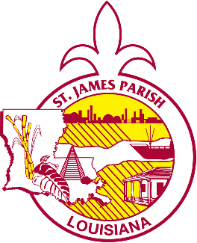





St. James Parish Government

COMMUNICATIONS

facebook.com/stjamesparishla www.stjamesla.com
225-264-3309

publicinformation@stjamesla.com

IMMEDIATE RELEASE
July 14th, 2025

Christmas in July: Economic Development Board Hosts West Bank Shopping Excursion

Vacherie, LA — The St. James Parish Economic Development Board invites locals and visitors alike to indulge in a festive afternoon of shopping and community spirit at the upcoming Christmas in July event. Scheduled for July 26th, 2025, this unique gathering promises an enjoyable blend of shopping, giveaways, refreshments, and an open house at St. Joseph’s Plantation

"We are thrilled to bring the community together for this festive occasion," said Brad Poche, St. James Parish Event Planner and Economic Development Board member. "It’s a wonderful opportunity to support our local businesses and enjoy a day out shopping on the West Bank."

From 12:00 noon to 4:00pm, participants can explore a variety of local businesses including Mon Amour, Oh Flowers, Vacherie Auto and Home Center, Oak Alley’s Gift Shop, Laura’s Gift Shop, and St. Joseph’s Gift Shop. Each venue will offer special promotions and a chance to discover unique gifts and treasures.

The event will feature an open house from 3:00pm-5:00pm hosted by the Economic Development Board at St. Joseph’s Plantation, located at 3535 Highway 18, Vacherie, from 3:00 p.m. to 5:00 p.m. Attendees can look forward to sampling delicious Cajun cuisine, enjoying giveaways, and experiencing the warm hospitality that St. James Parish is renowned for.

For more information, please call the St. James Parish Welcome Center at 225-562-2520.

